

PROJECT REPORT

**BANK MANAGEMENT SYSTEM**

**Submitted by :** Anishka Narang

**Registration No. :** 25BAI10513

**Course :** Python Essentials

INTRODUCTION

The project **Bank Management System** presented here represents a pivotal solution in the realm of financial management with the dynamic capabilities of Python. This amalgamation results in a comprehensive system that caters to both administrative and user functionalities, streamlining processes related to account management, feedback collection, and loan tracking.

**Evolution of Management Systems using Python**

The evolution of management systems, especially in the banking sector, has witnessed a paradigm shift with the advent of powerful programming languages like Python. Python, recognized for its simplicity, readability, and versatility, serves as the ideal frontend language for developing user-friendly interfaces.

The integration of these technologies facilitates a seamless flow of data, enabling real-time interactions between users and the banking system.

**Purpose of the Bank Management System**

The Bank Management System project aims to address several key challenges in traditional banking operations. By leveraging Python's intuitive programming features the system provides an agile and user-centric platform for both customers and administrators.

PROBLEM STATEMENT

Problem

* Current manual/unstructured banking records are inefficient, prone to error, and lack auditing capabilities.

Solution Goal

* Develop a secure, reliable, and user-friendly console application to manage core banking operations (accounts, transactions, balances) using Python.

Functional Requirements

**1. Account Management Module**

This module handles all creation and viewing of accounts.

* **Create New Account:** Allows a new customer to open a savings or checking account with an initial deposit and generates a unique Account ID and PIN.
* **View Account Details:** Retrieves and displays the full details (Name, ID, Balance, Account Type) for a given Account ID.
* **Close Account:** Allows a user to close an existing account after validating their PIN/credentials.

**2. Transaction Module**

This module handles money movement, which is the most critical feature of a bank.

* **Deposit:** Adds funds to a specified account after validation.
* **Withdrawal:** Removes funds from a specified account, including a check for sufficient balance and minimum balance constraints.
* **Transfer:** Moves funds from one account to another, requiring checks on both source and destination accounts.

**3. Reporting & Audit Module**

This module provides administrative or user-focused summary features.

* **View Balance:** Quickly check the current balance of an account.
* **Transaction History:** Displays a list of recent transactions (Deposits, Withdrawals, Transfers) for a specified period or number of entries.
* **System Audit Log:** Logs all failed login attempts, critical system errors, and account creation/deletion events.

NON-FUNCTIONAL REQUIREMENTS

**1. Security**

* All sensitive data (PINs/Passwords) must be stored in a **hashed and salted** format (e.g., using Python's hashlib or bcrypt). The system must enforce a PIN lockout after **three consecutive failed attempts**.

**2. Reliability & Error Handling**

* The system must implement robust **transaction integrity**. If a fund transfer fails halfway (e.g., withdrawal succeeds but deposit fails), the system must **rollback** the transaction to ensure no data is lost and balances are correct. All I/O operations must use try...except blocks to handle file/database access errors gracefully.

**3. Usability**

* The command-line interface (CLI) must use a clear, **menu-driven structure**. All system messages must be presented in **clear, non-technical language** (e.g., "Insufficient balance." instead of "Error Code 403").

**4. Maintainability**

* The core business logic (e.g., balance calculation, data validation) must be separated into a dedicated **Bank Manager class** or package, distinct from the user interface module. This allows the core logic to be easily updated or reused without modifying the UI.

SYSTEM ARCHITECTURE

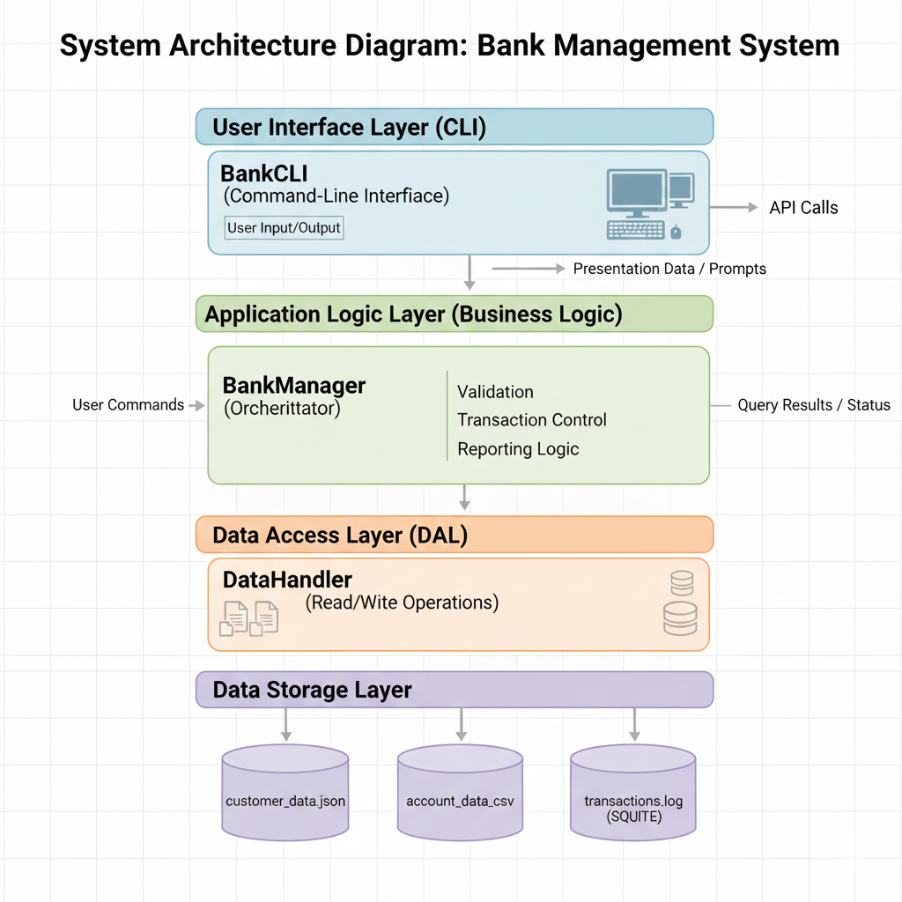

DESIGN DIAGRAMS

1 Use Case Diagram

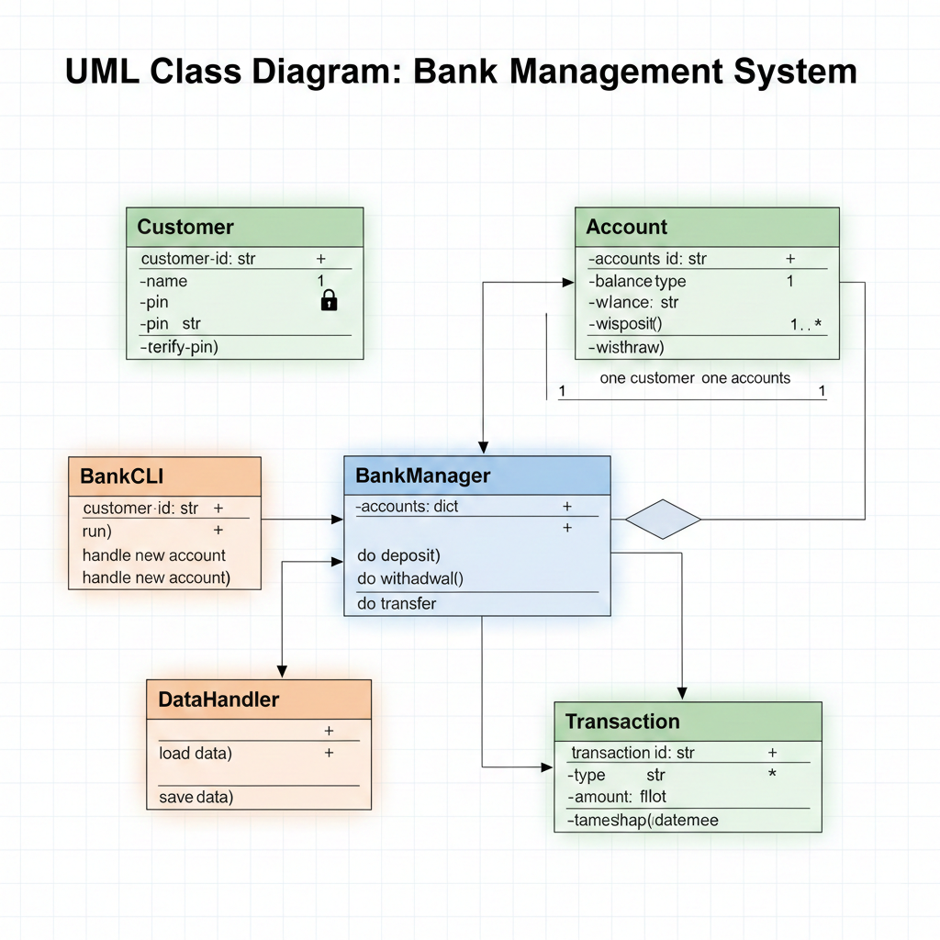

2 Workflow Diagram

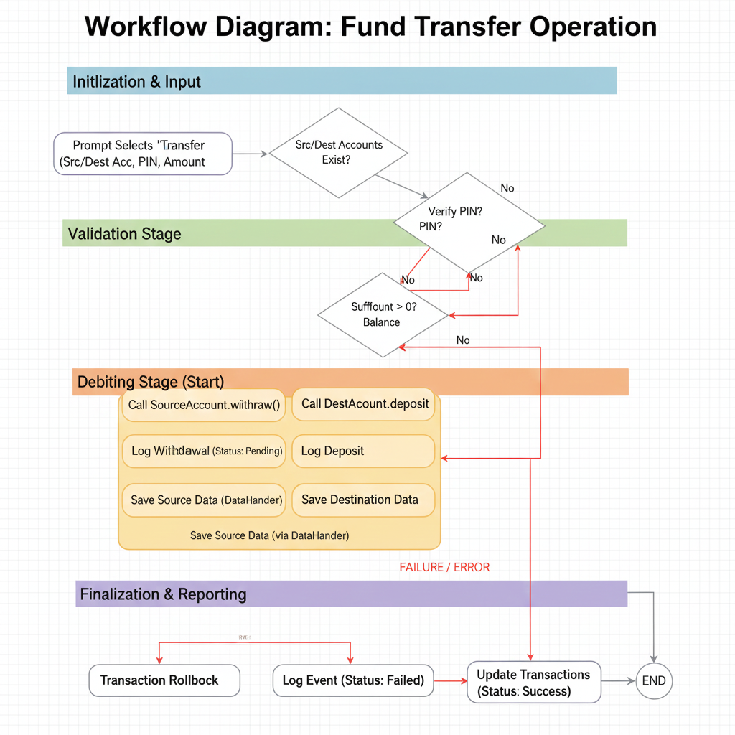

3 Sequence Diagram

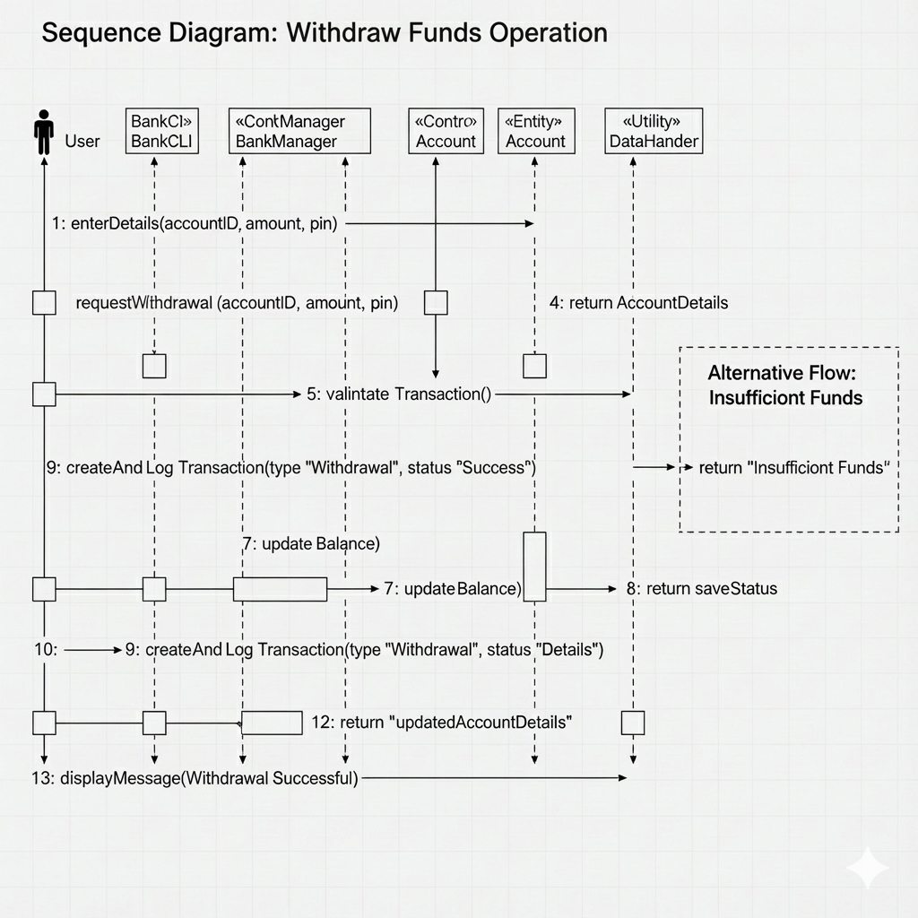

4 Class Diagram

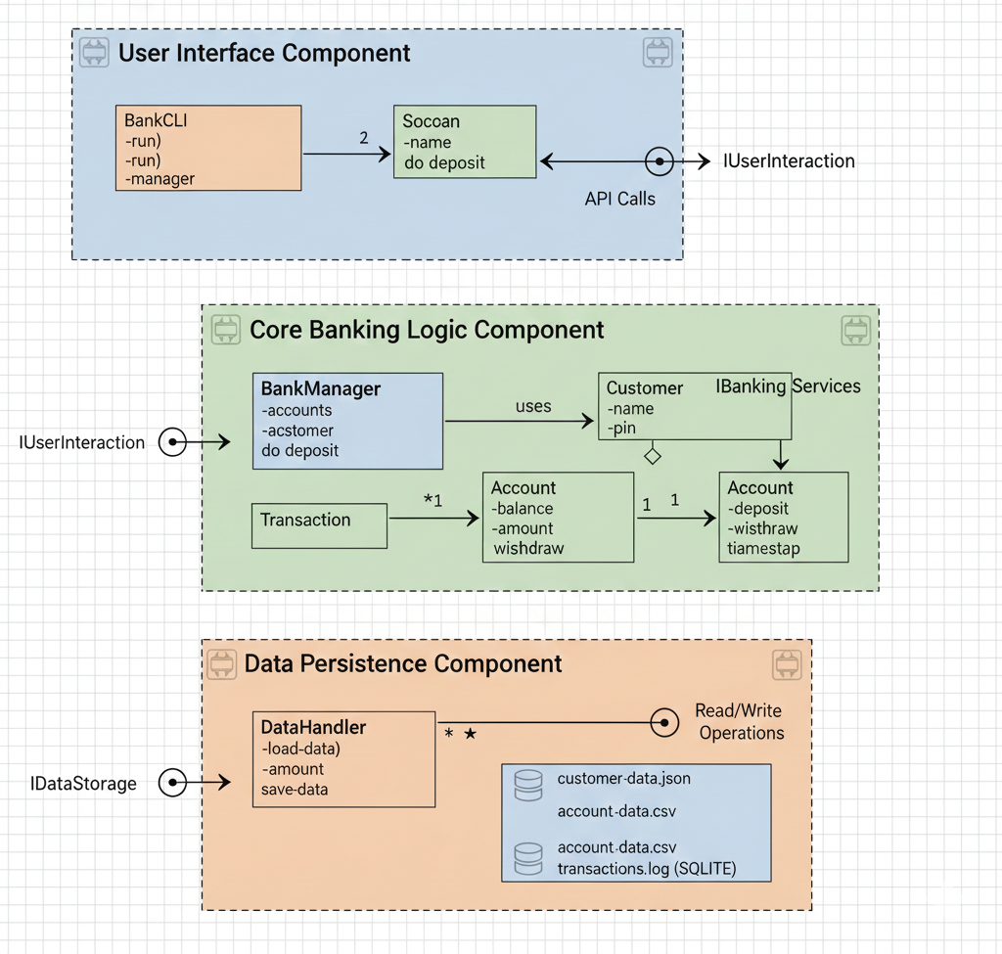

5 ER Diagram

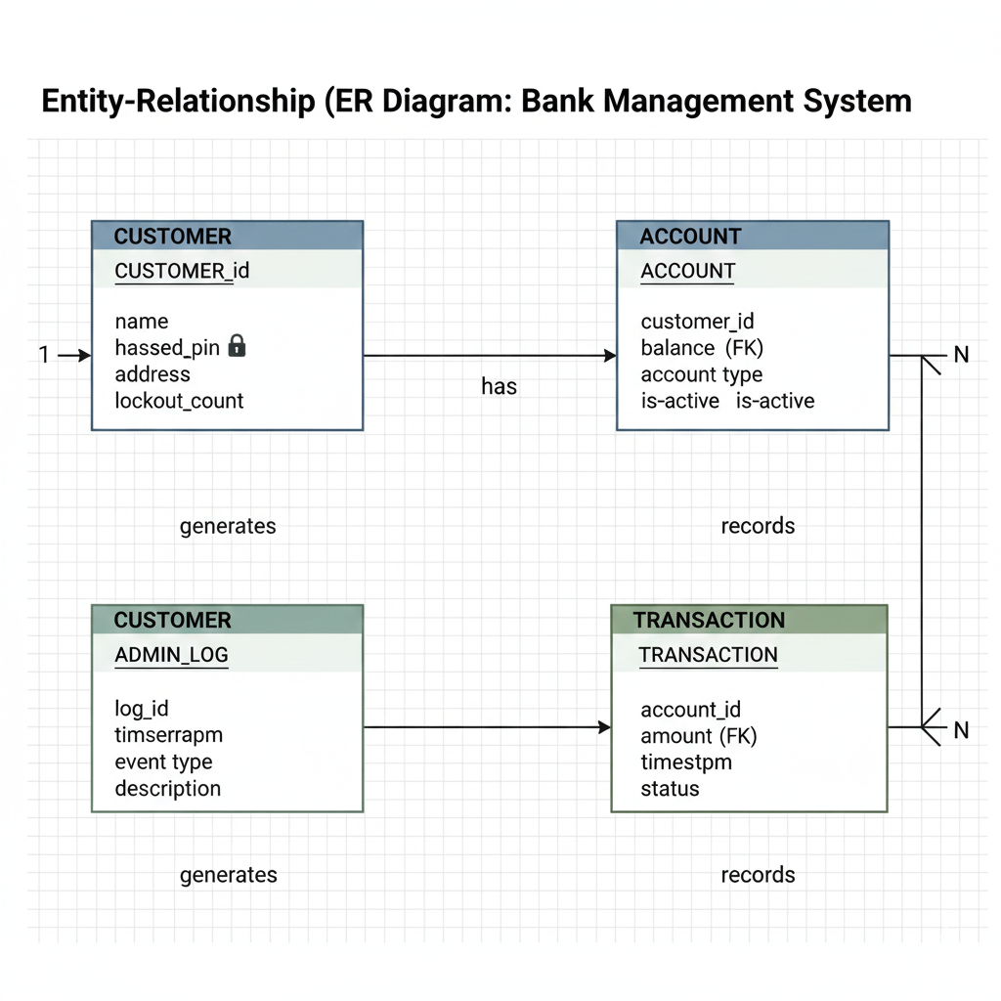

DESIGN DECISIONS & RATIONALE

* + **OOP Approach:** Using classes (Account, Customer, Bank Manager) for better **Maintainability** and modeling real-world entities.
  + **Modular Separation:** Clear distinction between the CLI and the Bank Manager for easy feature expansion.
  + **Hashed PINs:** Rationale for using cryptographic hashing to meet the **Security** NFR.
  + **Transaction Integrity:** The decision to implement a **rollback mechanism** during transfers to ensure **Reliability**.

IMPLEMENTATION DETAILS

**Project Structure (Folder/Package Structure)**

The project adheres to a proper folder structure, ensuring modules are easily maintainable and importable. This satisfies the minimum requirement of 5-10 meaningful files/modules.

BankManagementSystem/

├── data/ # Storage (JSON files)

│ └── users.json

├── logs/ # Logging requirement

│ └── system.log

├── src/ # Source Code [cite: 104]

│ ├── __init__.py

│ ├── models.py # Data Classes

│ ├── services.py # Business Logic (Functional Modules)

│ ├── utils.py # Helpers (Security/Logging)

│ └── main.py # Entry Point/UI

├── README.md # Required by [cite: 85]

└── statement.md # Required by [cite: 97]

SCREENSHOTS OF RESULT

Creating an account

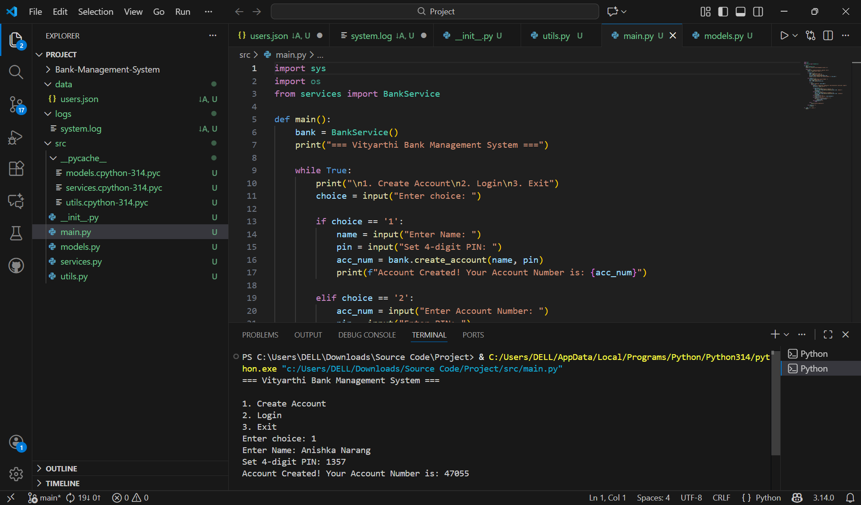

Login into existing account

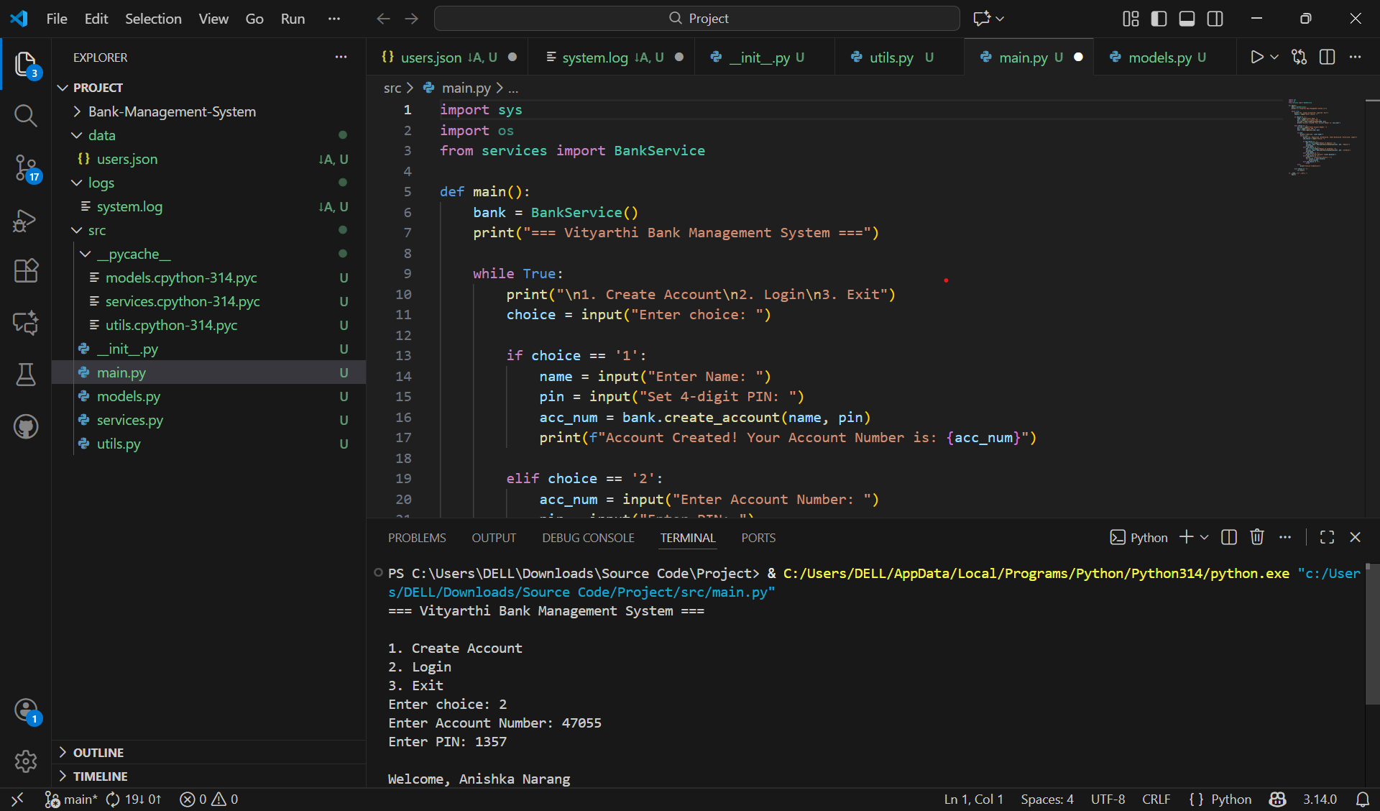

Depositing amount

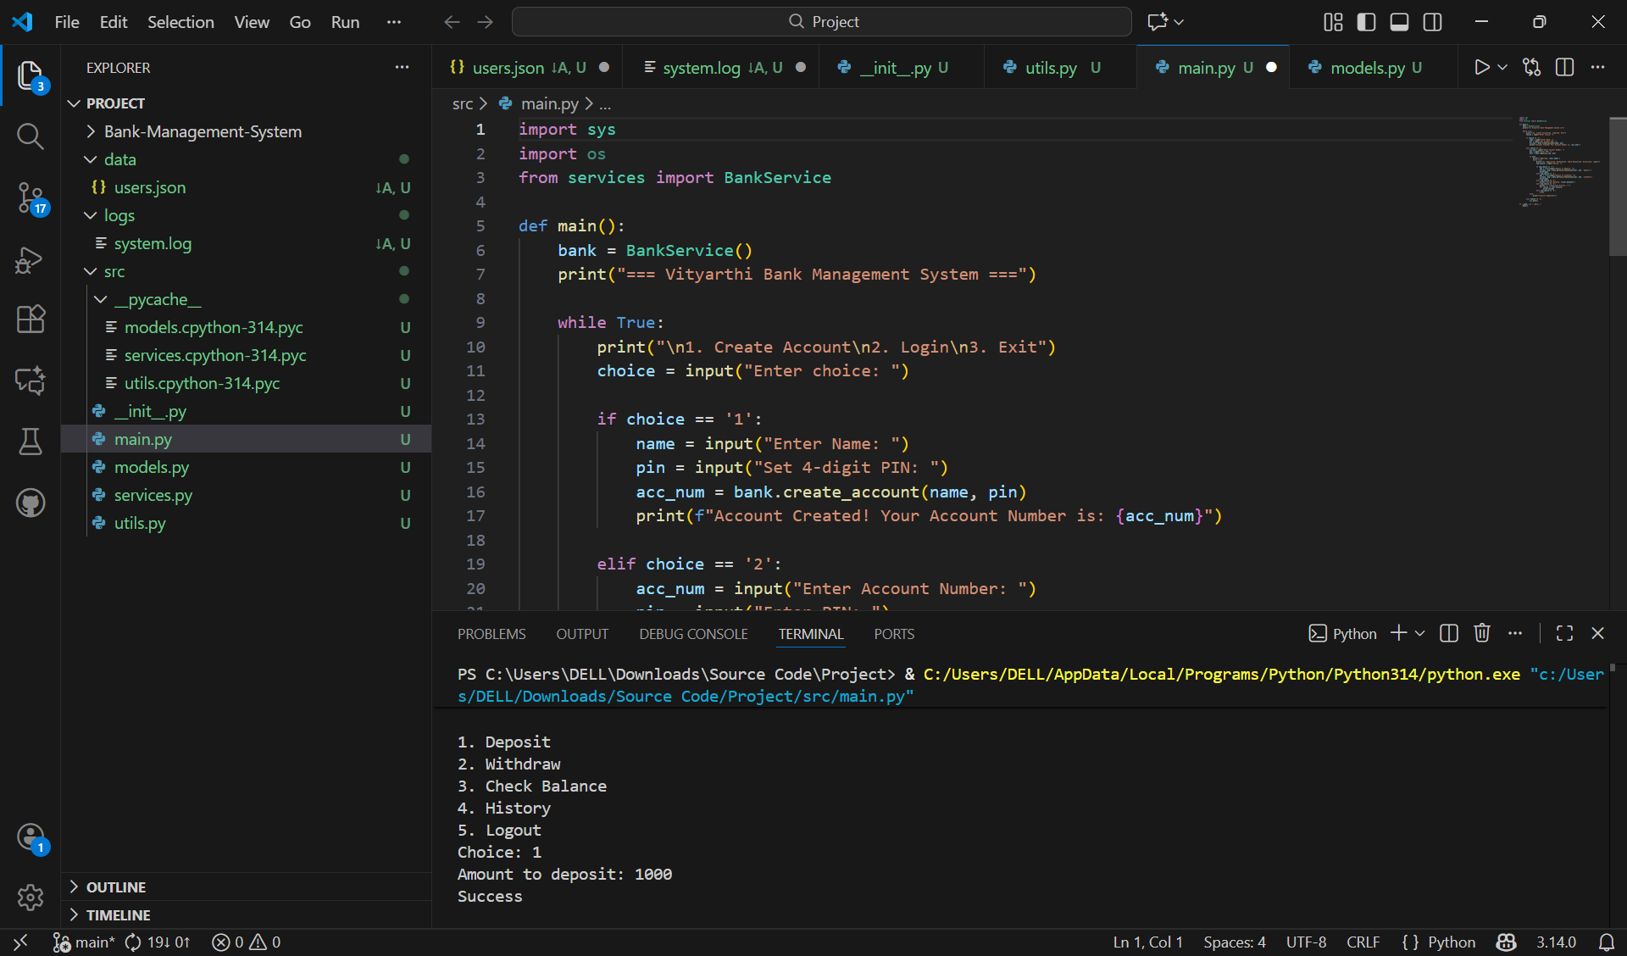

Withdrawing amount

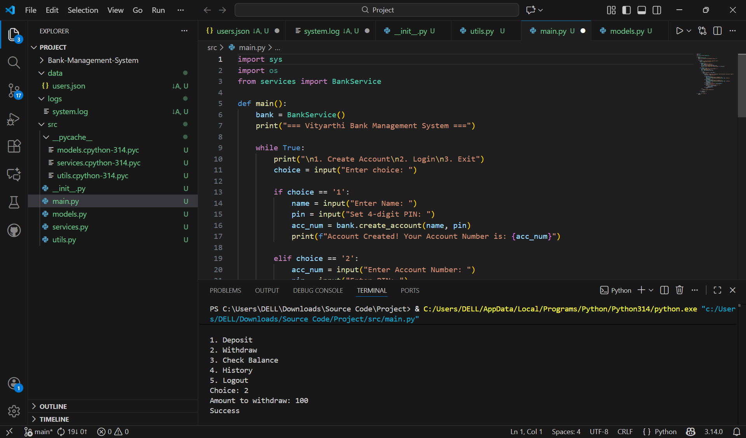

Checking balance

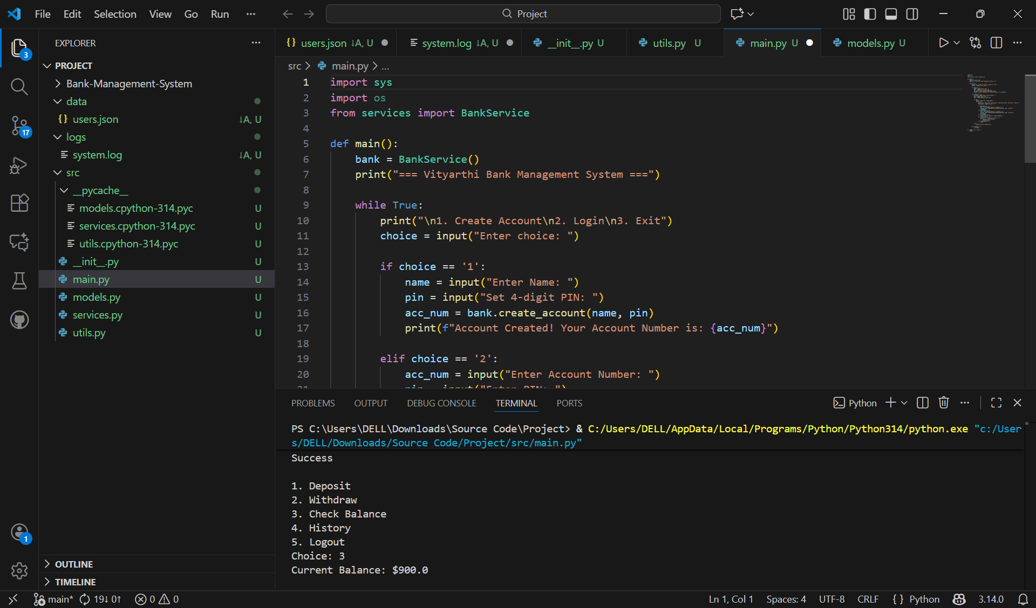

Viewing history

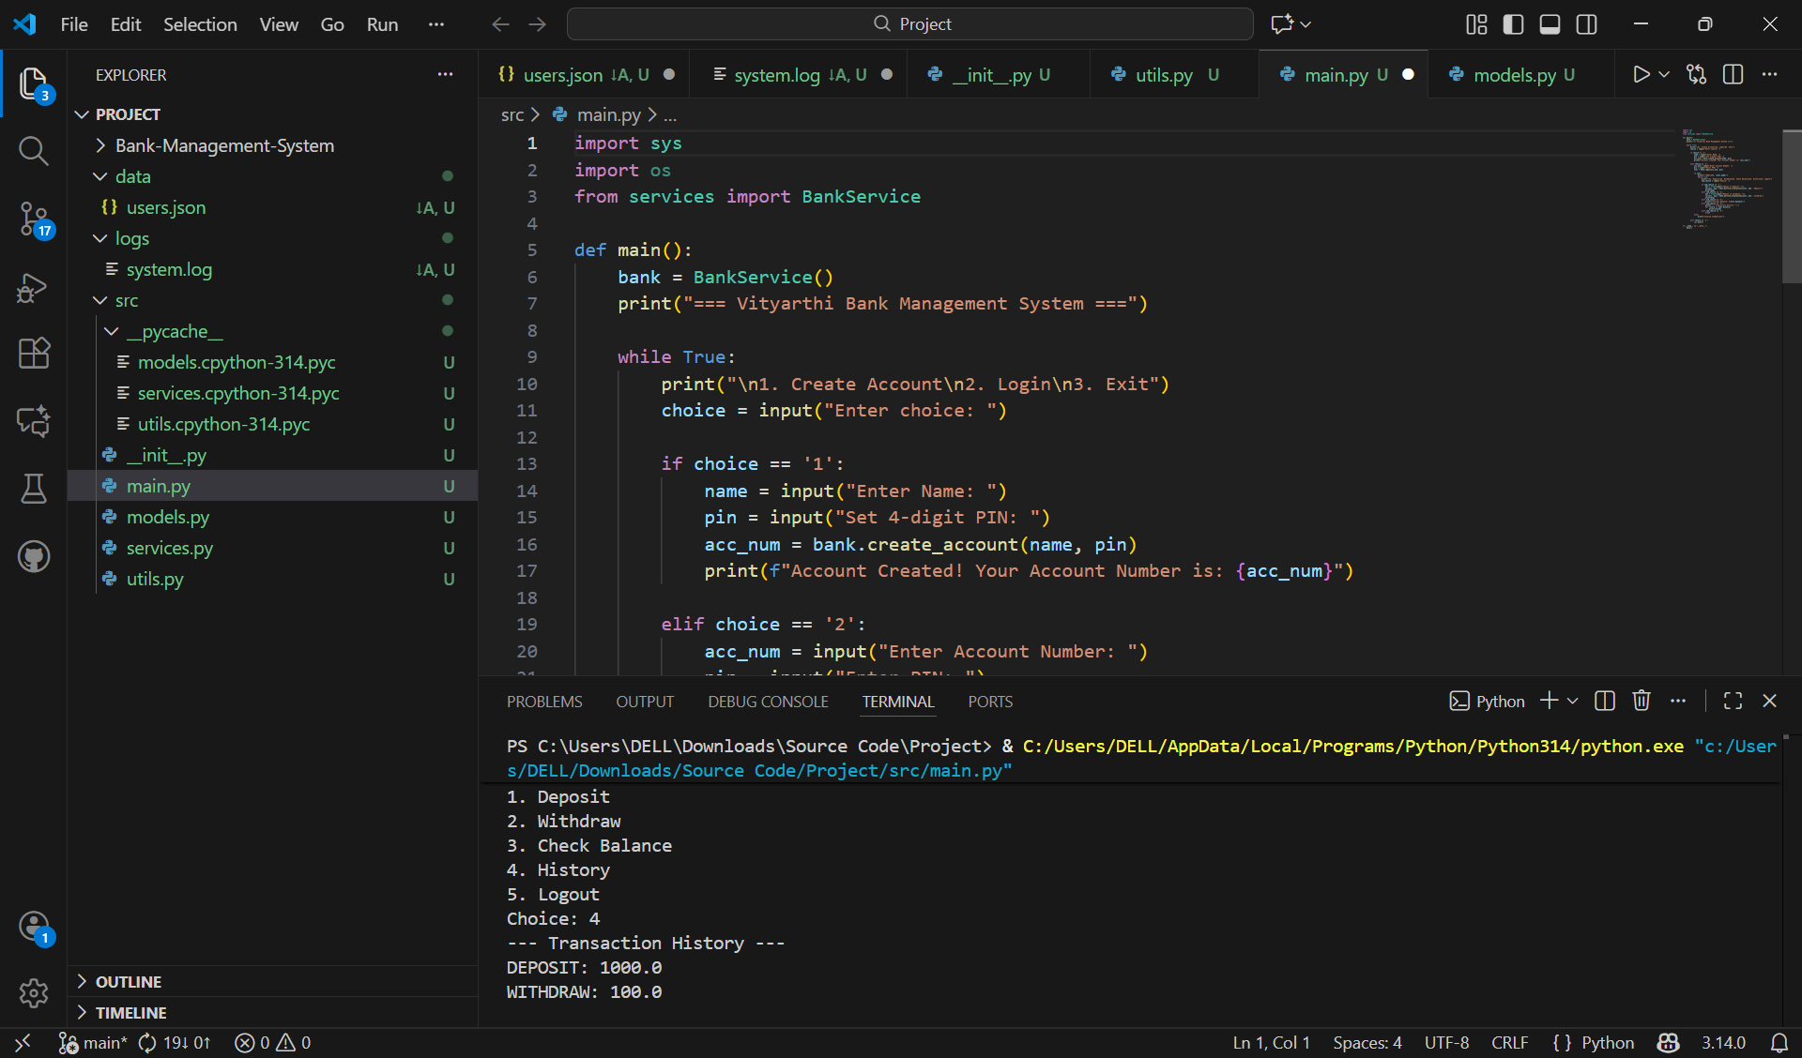

Logout & exit

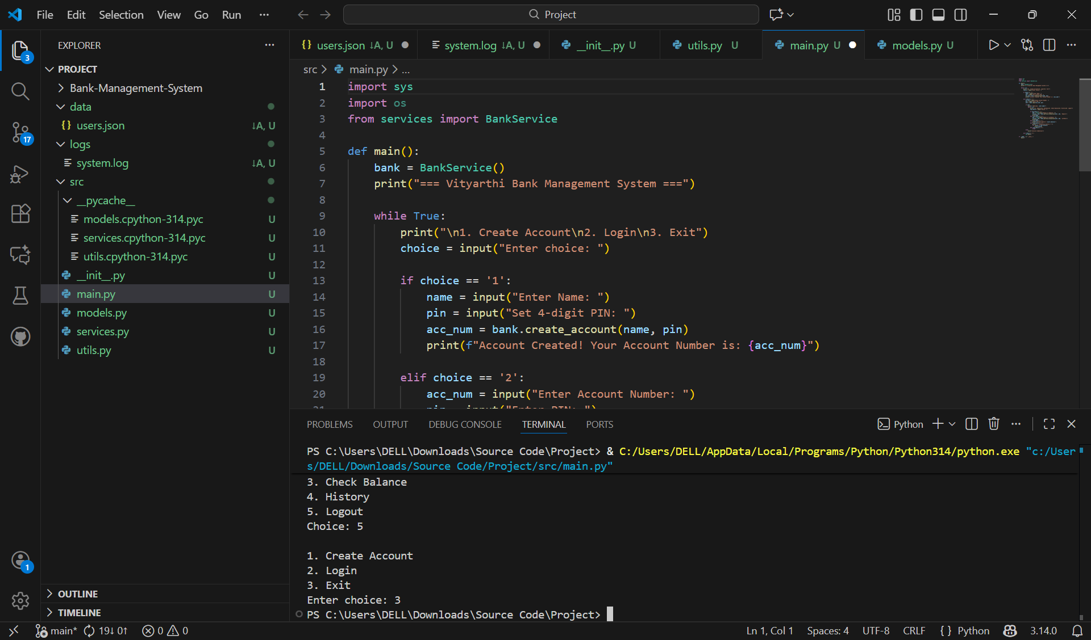

TESTING APPROACH

**Unit Testing Strategy**

Unit tests focus on isolating individual methods within the Account and Bank Manager classes to ensure core logic is defect-free.

| Component Tested | Test Case Description | Expected Result / Validation |
| --- | --- | --- |
| Account.withdraw() | Attempt withdrawal greater than current balance. | Must raise a custom InsufficientFundsError. |
| BankManager.do_deposit() | Deposit a valid positive amount. | Account balance increases by the exact amount; a **Transaction** object is logged. |
| Customer.verify_pin() | Attempt login with correct and incorrect PINs. | Correct PIN returns True; Incorrect PIN returns False and increments the lockout_count. |

CHALLENGES FACED

**1 Ensuring Transaction Integrity (The Rollback Problem)**

* **Challenge:** The most significant challenge was guaranteeing the **Reliability** Non-Functional Requirement, specifically ensuring that a **Fund Transfer** was always atomic (all-or-nothing). If the system crashed or an error occurred after money was debited from the source account but before it was credited to the destination account, the money would be lost, violating integrity.
* **Solution Implemented:** We implemented a **two-phase update strategy**.
  1. We made the crucial decision to update the source account's balance **first** and log the withdrawal transaction as **'Pending'** in the persistent storage.
  2. If the subsequent deposit failed, the Bank Manager automatically executed a **rollback function**. This function read the transaction log for any 'Pending' transactions, reversed the change to the source account's balance, and logged the event as **'Failed'**. This safeguard prevents data loss and maintains balance accuracy.

**2 Implementing Secure Data Handling**

* **Challenge:** Satisfying the **Security** NFR meant ensuring customer PINs were never stored in plaintext. Implementing secure hashing correctly, including the necessary imports and handling of the resulting byte string, was a key technical challenge.
* **Solution Implemented:** We utilized Python's hashlib**library** to apply a strong hashing algorithm (like SHA-256) combined with **salting** (appending a unique, random string to the PIN before hashing). This makes the PIN unusable even if the data file is compromised, as the hash cannot be easily reversed or looked up in rainbow tables.

**3 Separation of Concerns**

* **Challenge:** Early in development, the BankCLI (user interface) module became bloated with data validation and business rules, making the code difficult to debug and test. This violated the **Maintainability** NFR.
* **Solution Implemented:** We strictly enforced the **System Architecture** design by refactoring all core banking logic (e.g., sufficient funds check, interest calculation, account creation flow) into the dedicated Bank Manager class. The BankCLI was then restricted to only handling user input and displaying output, significantly increasing the project's **modularity** and ease of maintenance.

LEARNINGS AND KEY TAKEAWAYS

**1 Deepened Understanding of Object-Oriented Programming (OOP)**

The most fundamental learning was the practical application of OOP principles:

* **Modeling Real-World Entities:** Successfully designing classes (Customer, Account, Transaction) to accurately represent real-world bank components.
* **Encapsulation in Practice:** Learning to use private attributes and accessors (get_balance(), withdraw()) to protect sensitive data like account balances and PINs from unauthorized external modification, which is crucial for system security.

**2 Mastery of Modular and Layered Architecture**

Building the system using the **three-tier architecture** (UI  Logic  Data) reinforced the concept of separation of concerns:

* **Maintainability and Scalability:** By strictly isolating the business rules in the Bank Manager from the file handling in DataHandler, it became clear how future changes (e.g., switching from file storage to a professional database) could be implemented without needing to rewrite the core transaction logic.
* **Code Reusability:** The Account methods (deposit, withdraw) became reusable building blocks, called not only by the CLI but also internally by the do_transfer method.

**3 Criticality of Data Integrity and Reliability**

The design and implementation of the **Fund Transfer** operation highlighted the absolute necessity of transactional integrity:

* **Atomic Operations:** The challenge of implementing the rollback mechanism provided hands-on experience in ensuring that complex operations are **atomic**—they either complete fully and correctly, or they leave the system state unchanged. This is a vital concept in computer science and database management.

FUTURE ENHANCEMENTS

**1 User Interface and Accessibility**

* **Graphical User Interface (GUI):** Migrate the current Command Line Interface (CLI) to a simple desktop GUI using Python libraries like **Tkinter** or **PyQt**. This would greatly enhance the **Usability** NFR, making the application more intuitive and accessible to non-technical users.
* **Accessibility Features:** Implement text-to-speech functionality for output messages to assist visually impaired users.

**2 Core Banking Functionality Expansion**

* **Interest Calculation:** Implement a new module within the Bank Manager to calculate and apply interest (simple or compound) to Savings Accounts daily or monthly, introducing a **time-based dependency** to the system.
* **Loan Management Module:** Introduce new entity classes (Loan, Borrower) and a module to handle loan application, approval, instalment tracking, and interest accrual. This would introduce significant **complexity** to the transaction processing.
* **Overdraft Protection:** Modify the withdraw() method to allow a negative balance up to a predefined limit, adding a service charge for overdrafts.

**3 Technical and Security Enhancements**

* **API Integration:** Create an API layer (using Python frameworks like Flask or FastAPI) over the Bank Manager class. This would allow the core banking logic to be consumed by other applications (e.g., a mobile app or web portal), significantly boosting **Scalability**.
* **Asynchronous Logging:** Shift the **Logging** functionality to an asynchronous process to ensure that writing to the audit log does not slow down critical transaction processing, improving **Performance**.
* **Advanced Authentication:** Replace simple PIN verification with Two-Factor Authentication (2FA) for sensitive transactions like transfers, further strengthening the **Security** NFR.

REFERENCES

● Python official documentation: <https://docs.python.org/3/>

● pandas documentation: <https://pandas.pydata.org/docs/>

● matplotlib documentation: <https://matplotlib.org/stable/contents.html>

● Vityarthi Python Essentials Course materials, VIT

● Various online Python programming tutorials and examples